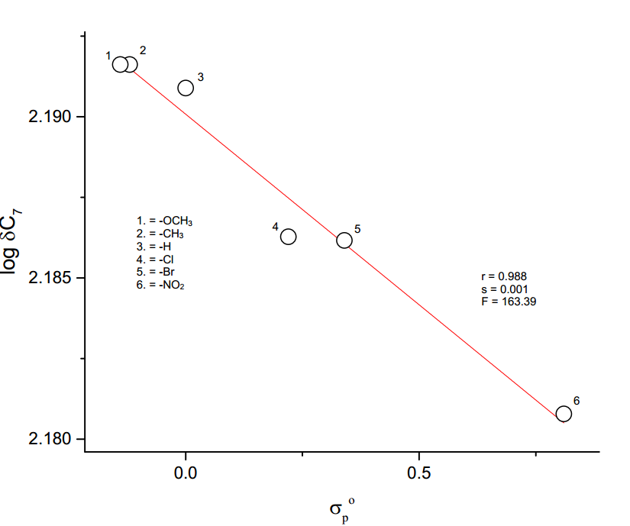

**Figure 3.11** The plot of log δ C7 vs *σpo*